Strategic Plan on a Page
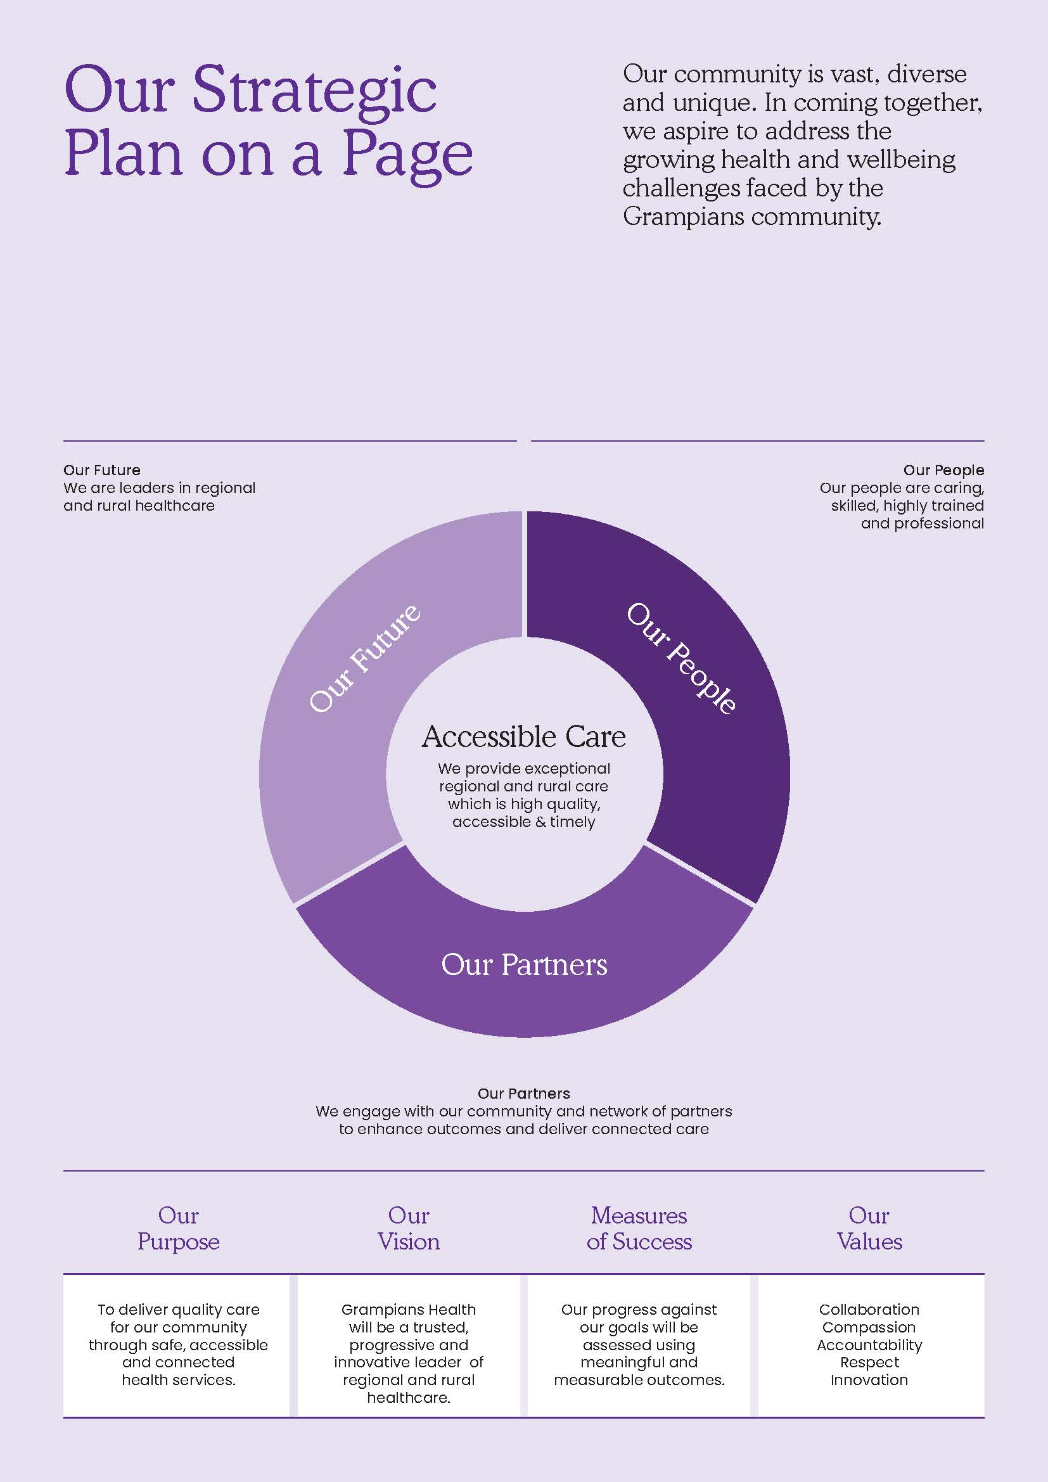
Information for the Consumer Partnership Program

